MEDIENINFORMATION
Würth Elektronik and Wirepas cooperate
Modules with Wirepas Mesh protocol for Massive IoT
Waldenburg (Germany), 15 December 2020 – Würth Elektronik has entered into a partnership with the Finnish software developer Wirepas. The aim of the agreement is to offer a portfolio of radio modules that use the IoT network protocol Wirepas Mesh from 2021. This innovative technology can be used to create large IoT networks, for example of battery-powered sensors, in which each participant also functions as a router. The mesh is self-healing and scalable as required. As part of an “early bird offer”, Würth Elektronik customers can receive from today the proven Proteus III / Thyone I hardware with firmware from Wirepas.
The design principles of the software stack from Wirepas were geared from the beginning to the requirements of the industry with regards to reliability, scalability and longevity of devices in battery operation. As a provider of compact and energy-saving radio modules in the 2.4 GHz band, Würth Elektronik is the ideal partner for manufacturing, selling and supporting ready-to-use radio modules for Wirepas mesh networks.
"This will make us a one-stop shop for companies willing to develop IoT solutions for remote monitoring and remote control of devices based on the extremely flexible and scalable Wirepas technology," explains Luca Settembre, product manager for GNSS and Wirepas in the Wireless Connectivity & Sensors Division at Würth Elektronik eiSos. “There are a lot of interested parties and developers who are urgently waiting for Wirepas radio modules available in smaller numbers. We have decided to be very flexible and offer a solution before the official start. "
Wirepas modules
With immediate effect, Würth Elektronik customers can receive their first radio module with Wirepas basic firmware. In cooperation with Wirepas, Würth Elektronik offers standard hardware in which the Wirepas firmware can be customized according to customer requirements. This means that an intelligent mesh network can be implemented for the customer within a very short time. The hardware is based on the Nordic chipset nRF52840, which has already proven itself very well at Würth Elektronik as the Bluetooth LE 5.1 ​​module Proteus-III or as the 2.4GHz proprietary radio module Thyone-I. From the end of Q1 2021, a standard radio module, like all products at Würth Elektronik eiSos, will be available from stock without a minimum order quantity.

Available images
The following images can be downloaded from the Internet in printable quality: http://www.htcm.de/kk/wuerth
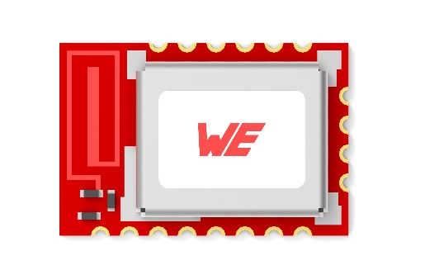
Image source: Würth Elektronik
Preview of the radio module that will use the IoT network protocol Wirepas Mesh.

About Wirepas
Wirepas is a leading IoT connectivity company focused on massive scale, low power IoT networks. Together with its ecosystem it boosts efficiency through asset tracking, smart logistics, smart lighting and diverse smart meters. Wirepas Mesh, a unique IoT connectivity software, is the only technology that allows an unlimited number of devices, even battery-powered, to create a network. This mesh network can be sparse or extremely dense, with up to a thousand devices in a cubic meter.
Wirepas serves customers across the world with offices in Australia, Brazil, Germany, Finland, France, India, South Korea and the United States.
For more information: wirepas.com

About the Würth Elektronik eiSos Group
Würth Elektronik eiSos Group is a manufacturer of electronic and electromechanical components for the electronics industry and a technology company that spearheads pioneering electronic solutions. Würth Elektronik eiSos is one of the largest European manufacturers of passive components and is active in 50 countries. Production sites in Europe, Asia and North America supply a growing number of customers worldwide.
The product range includes EMC components, inductors, transformers, RF components, varistors, capacitors, resistors, quartz crystals, oscillators, power modules, Wireless Power Transfer, LEDs, sensors, connectors, power supply elements, switches, push-buttons, connection technology, fuse holders and solutions for wireless data transmission.
The unrivaled service orientation of the company is characterized by the availability of all catalog components from stock without minimum order quantity, free samples and extensive support through technical sales staff and selection tools.
Through its technology partnership with the Audi Sport ABT Schaeffler Formula E Team and its support for the Formula Student racing series, the company demonstrates its innovative strength in eMobility
(www.we-speed-up-the-future.com).
Würth Elektronik is part of the Würth Group, the world market leader for assembly and fastening technology. The company employs 7,300 staff and generated sales of 822 million euros in 2019.
Würth Elektronik: more than you expect!
Further information at www.we-online.com

Further information:  Würth Elektronik eiSos GmbH & Co. KG  Sarah Hurst  Max-Eyth-Strasse 1  74638 Waldenburg  Germany  Phone: +49 7942 945-5186  E-mail: sarah.hurst@we-online.de  www.we-online.de | Press contact:  HighTech communications GmbH  Brigitte Basilio  Brunhamstrasse 21  81249 Munich  Germany  Phone: +49 89 500778-20  Telefax: +49 89 500778-77  E-mail: b.basilio@htcm.de  www.htcm.de

