PRESS RELEASE
New Würth Elektronik Automotive Components Catalog
Certified Components for Automotive Electronics
Waldenburg (Germany), 14 January 2021—Würth Elektronik has published a new catalog of AEC-Q200 certified components for automotive electronics. Product highlights include new ferrites, inductors and particularly robust electromechanical components. Design kits from many product groups are available for developers—as sample sets with free refill service.
With WE-TEMA, Würth Elektronik offers an innovative series of ferrites for cable assembly, some variants of which use new, innovative materials like nanocrystalline and manganese-zinc. The range of high-frequency inductors is now complemented with the WE-MCI product family. With their inductance ranging from 1 nH up to 470 nH, the multilayer ceramic inductors cover a wide variety of application areas. The WE-MAIA SMT series of storage chokes has been extended with package sizes 1610, 5020, 5030, 4020HT.
Würth Elektronik presents its new WE-SCFA contact fingers, certified for the special requirements in automotive applications and with WE-SMSA SMT spacer bolts.
Besides detailed product information in several chapters, the new automotive catalog also provides extensive background and design knowledge as well as a series of practical application examples. The Würth Elektronik Automotive Components Catalog is now available in English at http://www.we-online.de/aspcatalogue21.

Available images
The following images can be downloaded from the Internet in printable quality: http://www.htcm.de/kk/wuerth

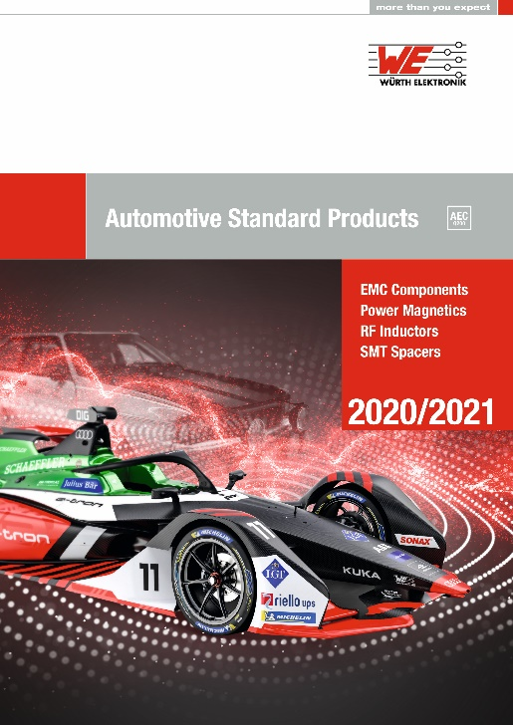
Image source: Würth Elektronik
Würth Elektronik Automotive Components Catalog

About the Würth Elektronik eiSos Group
Würth Elektronik eiSos Group is a manufacturer of electronic and electromechanical components for the electronics industry and a technology company that spearheads pioneering electronic solutions. Würth Elektronik eiSos is one of the largest European manufacturers of passive components and is active in 50 countries. Production sites in Europe, Asia and North America supply a growing number of customers worldwide.
The product range includes EMC components, inductors, transformers, RF components, varistors, capacitors, resistors, quartz crystals, oscillators, power modules, Wireless Power Transfer, LEDs, sensors, connectors, power supply elements, switches, push-buttons, connection technology, fuse holders and solutions for wireless data transmission.
The unrivaled service orientation of the company is characterized by the availability of all catalog components from stock without minimum order quantity, free samples and extensive support through technical sales staff and selection tools.
Through its technology partnership with the Audi Sport ABT Schaeffler Formula E Team and its support for the Formula Student racing series, the company demonstrates its innovative strength in eMobility
(www.we-speed-up-the-future.com).
Würth Elektronik is part of the Würth Group, the world market leader for assembly and fastening technology. The company employs 7,300 staff and generated sales of 822 million euros in 2019.
Würth Elektronik: more than you expect!
Further information at www.we-online.com

Further information:  Würth Elektronik eiSos GmbH & Co. KG  Sarah Hurst  Max-Eyth-Strasse 1  74638 Waldenburg  Germany  Phone: +49 7942 945-5186  E-mail: sarah.hurst@we-online.de  www.we-online.de | Press contact:  HighTech communications GmbH  Brigitte Basilio  Brunhamstrasse 21  81249 Munich  Germany  Phone: +49 89 500778-20  Telefax: +49 89 500778-77  E-mail: b.basilio@htcm.de  www.htcm.de

