PRESS RELEASE
Sartorius Electronics counts on ASM equipment
Certified leap in quality and performance
Suwanee (USA), March 29, 2021 – Sartorius Electronics, the in-house electronics manufacturer of the Life Science Group Sartorius, relies for its newest production line on coordinated printing, SPI and placement solutions of SMT technology leader ASM. And it does so with great success, because the company was able to increase its first pass yield, quality and productivity considerably. Having the line certified as per IPC-J-STD-001 and IPC-A-610 also put Sartorius Electronics as the first German company on the IPC list of qualified manufacturers (QML).
Sartorius Electronics, which functions as the internal supplier of electronic modules for the Sartorius Group, has also been operating for 25 years as a provider of electronics manufacturing services (EMS) for the general market with great success. As a center of competence for module production, Sartorius Electronics employs all components of the DfX (Design for Excellence) approach. In 2020, 129 initial sample jobs and 842 active jobs resulted in roughly 710,000 modules leaving the production lines.
The rapidly rising in-house demand for electronic modules, component miniaturization and new applications made it necessary to modernize one of the two production lines. Sartorius selected equipment from SMT technology leader ASM: “The core requirements of our internal and external customers are primarily speed for the initial sample process as well as great flexibility and high quality in the production of predominantly small and medium lot sizes. ASM was able to offer an overall solution that was optimized for the needs of Sartorius Electronics,” explains Christoph Oeckl, who heads the ASM SMT Center of Competence in Munich.
Speed, precision, and maximum flexibility
The DEK NeoHorizon 03iX stencil printer achieves a precision of up to ±25 µm @ > 2.0 Cpk with a standard cycle time of eight seconds. ASM ProcessExpert, the world’s first self-learning expert system for printing process control, continuously monitors and optimizes the printing process proactively and autonomously. The DFM HealthCheck function additionally checks the stencil designs for their process stability and uses virtual prints to automatically set the right printing and process parameters for new product introductions. Two SIPLACE SX placement machines with SIPLACE MultiStar and SIPLACE TwinStar heads feature high precision and speed for placing components ranging from the 0201 metric size to large and heavy odd-shaped components.
SMT production on a new level
In the first six months after commissioning the new ASM line, Sartorius could improve its first pass yield to 99.36 percent and reduce the reject rate to as little as 0.53 percent.
“We consider the introduction of the ASM line to a success. We were able to raise our quality, process reproducibility and productivity while enjoying a level of support that is truly impressive in terms of type and scope,” says Thomas Eckart, manager of Sartorius Electronics. “The ASM ProcessExpert has been a significant advance not only in our initial sample development. The certifications as per the IPC-J-STD-001 and IPC-A-610 standards would have been impossible without the support from ASM’s experts,” adds Stefan Brandt, team lead and head of quality management at Sartorius Electronics.
Smart expansions are already planned
Since Sartorius will soon need more feeder slots on the new line due to further increases in component diversity and placement volume, it plans to install a solution that has no equal in the industry: the SIPLACE SX+, a placement solution with no gantry and no head, but to which a gantry and head can be transferred from an existing machine in less than 30 minutes. It allows the user to instantly increase the number of feeder slots in the line by 33 percent without having to invest in more placement heads and more performance that may not be needed. “Our solution scales with the need for additional feeder slots, is cost-attractive, and provides Sartorius with the freedom to add more performance to the line in the future,” explains Christoph Oeckl.

Illustrations for downloading

The following printable illustrations are available for downloading:
http://www.htcm.de/kk/asm
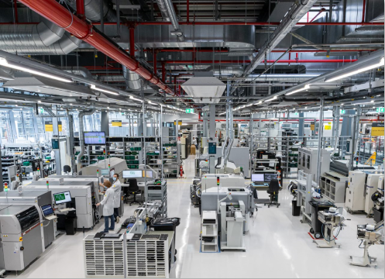  Image: Sartorius Electronics  The Electronics department of the Sartorius Life Sciences Group also works as an EMS provider for external customers. In 2020, roughly 710,000 modules left the production lines. | 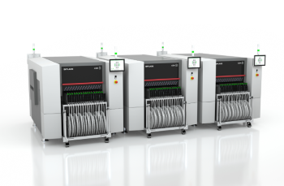  Image: ASM  The SIPLACE SX features flexible production through on-demand scaling, many feeder and conveyor options, special processes such as clinching, a broad component spectrum, and placement performance of up to 86,500 cph.

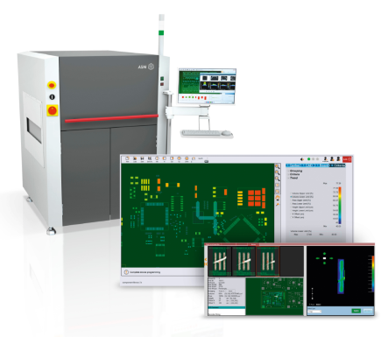  Image: ASM  ASM ProcessExpert, the world’s first self-learning inline SPI expert system, played a key role and the successful IPC certification of Sartorius Electronics. | 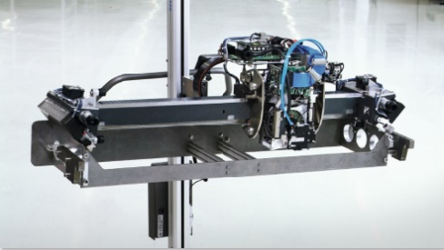  Image: ASM  With placement head changes in only 30 minutes, SIPLACE interchangeable gantries delivers exceptional flexibility for high-mix production environments.

The SMT Solutions segment of ASM Pacific Technology
The mission of the SMT Solutions segment within the ASM Pacific Technology Group (ASMPT) is to implement and support the smart SMT factory at electronics manufacturers worldwide.
ASM solutions such as SIPLACE placement systems and DEK printing systems support the networking, automation and optimization of central workflows with hardware, software and services that enable electronics manufacturers to transition to the smart SMT factory in stages and enjoy dramatic improvements in productivity, flexibility and quality.
Since maintaining close relationships with customers and partners is a central component of ASM’s strategy, the company has established the SMT Smart Network as a global forum for the active exchange of information between and with smart champions. In addition to being a founding member of the ADAMOS joint venture for the development of an IIoT platform for manufacturing companies, ASM is establishing together with other SMT manufacturers the open HERMES standard as a successor to the SMEMA standard for M2M communication in SMT lines.
For more information about ASM visit www.asm-smt.com.

ASM Pacific Technology Limited
Headquartered in Singapore, ASMPT (HKEX stock code: 0522) is a global technology and market leader in leading-edge solutions and materials for the semiconductor assembly and packaging industries. Its surface mount technology solutions are deployed in a wide range of end-user markets including electronics, mobile communications, automotive, industrial, and LED. The company’s continuous investments in research and development help to provide its customers with innovative and cost-efficient solutions and systems that enable them to achieve higher productivity, greater reliability and enhanced quality.
For more information about ASMPT visit www.asmpacific.com.

Press contacts:
AMCAS ASM Press Office
ASM Assembly Systems GmbH & Co. KG
Mark Ogden
Tel.: +1 (770) 797 3189
E-mail: ogden.mark@asmpt.com
Website: www.asm-smt.com

Global ASM Press Office
ASM Assembly Systems GmbH & Co. KG
Susanne Oswald
E-mail: susanne.oswald@asmpt.com
Website: www.asm-smt.com

