PRESS RELEASE
Würth Elektronik extends its product group of WE-HCM high-current inductors
Low Space Requirement, Best Values
Waldenburg (Germany), 24 March 2021—One of Würth Elektronik’s most important SMT high-current inductor innovations is to expand its WE-HCM series portfolio with 1012, 4030 and 5030 packages. The flat-wire coils with MnZn core are characterized by extremely low resistance, low core losses, and a very high current carrying capacity. With their small footprint, the devices are the first choice of developers and manufacturers for new, more compact device designs.
The WE-HCM1012 high-current inductor takes up just 10x6 mm of space on the board and accommodates its flat-wire coil in a 12 mm high package. The rated current of 84 A and saturation current over 125 A are also high. WE-HCM1012 is available in variants with inductances of 0.07 µH 0.1 µH, 0.12 µH and 0.15 µH.
The two new WE-HCMs in 4030 and 5030 packages are also unusually space-saving in their footprint and height. As they are only 3 mm high, they are suitable for use in convertible notebooks and tablets, for example. Applications include multiphase switching regulators, CPU/RAM power supply, power PC or graphics cards. Their saturation current goes up to 45 A and the rated current is 59 A. All WE-HCM versions are specified for an operating temperature range from -40 to +125°C.
The new WE-HCM are now available from stock without a minimum order quantity. Würth Elektronik provides developers free samples on request.

Available images
The following images can be downloaded from the Internet in printable quality: http://www.htcm.de/kk/wuerth

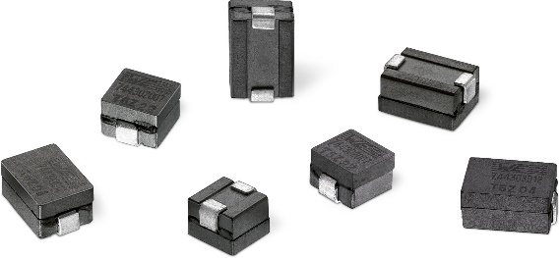
Image source: Würth Elektronik
SMT-mountable high-current inductors of the WE-HCM series in 1012, 4030 and 5030 packages

About the Würth Elektronik eiSos Group
Würth Elektronik eiSos Group is a manufacturer of electronic and electromechanical components for the electronics industry and a technology company that spearheads pioneering electronic solutions. Würth Elektronik eiSos is one of the largest European manufacturers of passive components and is active in 50 countries. Production sites in Europe, Asia and North America supply a growing number of customers worldwide.
The product range includes EMC components, inductors, transformers, RF components, varistors, capacitors, resistors, quartz crystals, oscillators, power modules, Wireless Power Transfer, LEDs, sensors, connectors, power supply elements, switches, push-buttons, connection technology, fuse holders and solutions for wireless data transmission.
The unrivaled service orientation of the company is characterized by the availability of all catalog components from stock without minimum order quantity, free samples and extensive support through technical sales staff and selection tools.
Through its technology partnership with the Audi Sport ABT Schaeffler Formula E Team and its support for the Formula Student racing series, the company demonstrates its innovative strength in eMobility
(www.we-speed-up-the-future.com).
Würth Elektronik is part of the Würth Group, the world market leader for assembly and fastening technology. The company employs 7,300 staff and generated sales of 823 million euros in 2020.
Würth Elektronik: more than you expect!
Further information at www.we-online.com

Further information:  Würth Elektronik eiSos GmbH & Co. KG  Sarah Hurst  Max-Eyth-Strasse 1  74638 Waldenburg  Germany  Phone: +49 7942 945-5186  E-mail: sarah.hurst@we-online.de  www.we-online.de | Press contact:  HighTech communications GmbH  Brigitte Basilio  Brunhamstrasse 21  81249 Munich  Germany  Phone: +49 89 500778-20  Telefax: +49 89 500778-77  E-mail: b.basilio@htcm.de  www.htcm.de

