PRESS RELEASE

Online series of Hufschmied Zerspanungssysteme GmbH
Successful Virtual Masterclass on carbon fiber reinforced thermoplastic composite materials
Bobingen (Germany), March 19, 2021 – "Effective machining of high-performance carbon fiber reinforced thermoplastic composite materials" was the title of the Hufschmied Virtual Masterclass that was held on March 4th, 2021 together with the material manufacturer Toray Advanced Composites and machine manufacturer Cms. A video from the processing of the Toray Cetex® TC1225 material with the Hufschmied tool 065SMCS is now available at https://youtu.be/kVwyxU6fkoM. Another online event from the Virtual Masterclass series is scheduled for April the 22nd.
Hufschmied's machining experts showed applicants and manufacturing managers online the 5-axis machining of Toray Cetex® TC1225 with the Hufschmied tool 065SMCS and explained the diamond coating and special geometry of the three-edged tool with chipbreakers. Machining videos showed that this roughing/finishing tool produces perfect surfaces in one step. Even a plate only 1.1 mm thick could be machined without problems at 16 000 rpm and 3 000 mm/min feed rate. The demonstrators provided by Toray had been machined at Cms in the large ARES 4818 high-speed 5-axis milling center.
"We are offering expert information for practitioners in the Virtual Masterclasses and are pleased that this time, too, participants from all over the world have been attending. The thin-walled Cetex® in particular shows how important the right tool for efficient machining of a thermoplastic composite is without any delamination or melting," says the moderator of the event, Heiko Simonis, Business Development at Hufschmied Zerspanungssysteme GmbH.

Available images
The following images can be downloaded from the Internet in printable quality:
http://www.htcm.de/kk/hufschmied
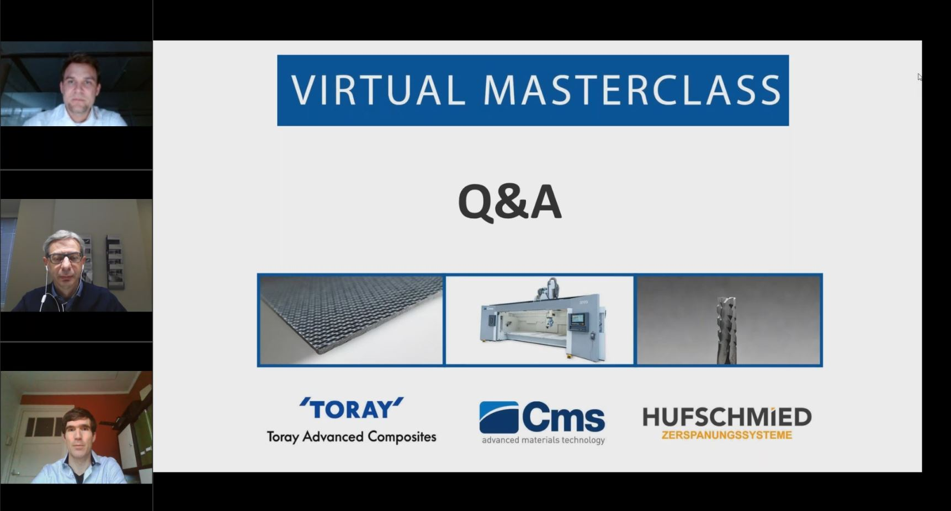 Source:  Hufschmied Zerspanungssystem  Together with the material manufacturer Toray Advanced Composites and machine manufacturer Cms, Hufschmied Zerspanungssysteme presented the online event "Virtual Masterclass" on March 4th. The material Toray Cetex® TC1225 was machined with the Hufschmied 065SMCS - can be viewed at https://youtu.be/kVwyxU6fkoM |   Source: Hufschmied Zerspanungssysteme  Heiko Simonis, Business Development at Hufschmied Zerspanungssysteme GmbH

About Hufschmied Zerspanungssysteme GmbH
Established in 1991 and headquartered in Bobingen near Augsburg, Hufschmied Zerspanungssysteme GmbH is a manufacturer of high-quality tools for machinable production. By specializing at an early stage in the machining of plastics, fiberglass materials and carbon fiber, Hufschmied has become a leader in Europe in the development of solutions for new materials. The company is an established system supplier to renowned machine tool manufacturers. Tools and manufacturing process consulting from Hufschmied are particularly valued in the automotive and aerospace industries as well as in medical technology. The company is involved in numerous organizations, including Composites United Deutschland e. V. Hufschmied's manufacturing operations are located in Winterlingen in the Swabian Alb.
For more information: www.hufschmied.net

Additional information:  Hufschmied Zerspanungssysteme GmbH  Sybille Schuller  Edisonstrasse 11d  86399 Bobingen  Germany  Phone: +49 8234 9664-0  Telefax: +49 8234 9664-99  E-Mail: info@hufschmied.net  www.hufschmied.net | Press contact:  HighTech communications GmbH  Brigitte Basilio  Brunhamstrasse 21  81249 Munich  Germany  Phone: +49 89 500778-20  Telefax: +49 89 500778-77  E-Mail: b.basilio@htcm.de  www.htcm.de

