PRESS RELEASE
Würth Elektronik extends its infrared-LED range
WL-SIQW – High Efficiency Infrared Light Source
Waldenburg (Germany), 3 March 2021—Würth Elektronik complements its infrared product range with the new WL-SIQW SMT Infrared QFN LED Waterclear product series. The LEDs in Quad Flat No Leads (QFN) format are available in 2720, 3535 and 3737 packages with different radiant intensities from 125 to 800 mW/sr and in 90°, 120° or 150° beam angles. Depending on the application, the infrared sources are available in wavelengths of 850 or 940 nm.
The SMT-mountable WL-SIQW components are suitable for a wide range of applications in the fields of infrared cameras, night vision, surveillance and security solutions, as well as face and motion detection, or biometric identification. With the compact QFN format, Würth Elektronik achieves excellent thermal properties for the powerful LEDs and ensures stable, reliable contacts on standard solder pads.
All WL-SIQW SMT Infrarot QFN LEDs are available from stock without a minimum order quantity. Würth Elektronik provides developers with free samples.

Available images
The following images can be downloaded from the Internet in printable quality: http://www.htcm.de/kk/wuerth

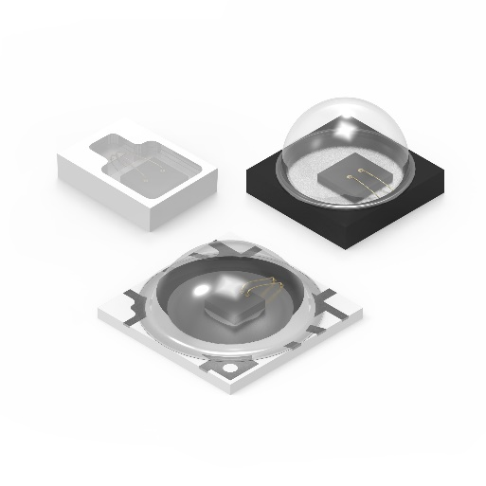Image source: Würth Elektronik
Infrared product range with new product series WL-SIQW SMT Infrared QFN LED Waterclear

Available videos
You can find the following videos on our YouTube channel:
https://www.youtube.com/watch?v=ii2eUkFOT2s
Source: Würth Elektronik
WE meet @ Digital Days 2020: Optoelectronics: Introduction of new products - Product presentation by Dr. Zhelio Andreev, Product Manager Optoelectronics at Würth Elektronik eiSos

About the Würth Elektronik eiSos Group
Würth Elektronik eiSos Group is a manufacturer of electronic and electromechanical components for the electronics industry and a technology company that spearheads pioneering electronic solutions. Würth Elektronik eiSos is one of the largest European manufacturers of passive components and is active in 50 countries. Production sites in Europe, Asia and North America supply a growing number of customers worldwide.
The product range includes EMC components, inductors, transformers, RF components, varistors, capacitors, resistors, quartz crystals, oscillators, power modules, Wireless Power Transfer, LEDs, sensors, connectors, power supply elements, switches, push-buttons, connection technology, fuse holders and solutions for wireless data transmission.
The unrivaled service orientation of the company is characterized by the availability of all catalog components from stock without minimum order quantity, free samples and extensive support through technical sales staff and selection tools.
Through its technology partnership with the Audi Sport ABT Schaeffler Formula E Team and its support for the Formula Student racing series, the company demonstrates its innovative strength in eMobility
(www.we-speed-up-the-future.com).
Würth Elektronik is part of the Würth Group, the world market leader for assembly and fastening technology. The company employs 7,300 staff and generated sales of 823 million euros in 2020.
Würth Elektronik: more than you expect!
Further information at www.we-online.com

Further information:  Würth Elektronik eiSos GmbH & Co. KG  Sarah Hurst  Max-Eyth-Strasse 1  74638 Waldenburg  Germany  Phone: +49 7942 945-5186  E-mail: sarah.hurst@we-online.de  www.we-online.de | Press contact:  HighTech communications GmbH  Brigitte Basilio  Brunhamstrasse 21  81249 Munich  Germany  Phone: +49 89 500778-20  Telefax: +49 89 500778-77  E-mail: b.basilio@htcm.de  www.htcm.de

